

MATHEMATICS
APPLICATIONS

Test 3 – Recurrence Relationships

Chapter 4
Semester 1 2017

Section Two - Calculator Assumed

Time allowed for this section
Working time for this section: 35 minutes
Marks available: 38 marks

Material required/recommended for this section

To be provided by the supervisor
This Question/Answer booklet
Formula sheet

To be provided by the candidate
Standard items: pens, pencils, pencil sharpener, eraser, correction fluid, ruler, highlighters

Special items: drawing instruments, templates, notes on one unfolded sheet of A4 paper, and up to three calculators satisfying the conditions set by the Curriculum Council for this course.

Important note to candidates
No other items may be used in this section of the examination. It is your responsibility to ensure that you do not have any unauthorised notes or other items of a non-personal nature in the examination room. If you have any unauthorised material with you, hand it to the supervisor before reading any further.
- (2 marks)
Write down the first five terms of the sequence defined by the recurrence relation:

- (2 marks)
The nth term of an arithmetic sequence is given by the rule:
Determine the recurrence relation.

- (7 marks)
A lump sum of money is invested in a savings fund that compounds interest annually.
The amount of money in the savings fund, , is given by the recursive rule , where and n is the number of years after the initial deposit.
  - State the initial amount of the lump sum. [1]

  - State the annual interest rate offered by the savings fund. [1]

  - Explain why the multiplication factor is 1.05 [1]

  - Determine
    - the amount of money, to the nearest cent, in the savings fund after four years. [2]

    - the amount of interest earned during the first year. [1]

    - the amount of interest accumulated during the first four years. [1]

- (8 marks)
A plant grew from a seed to a height of 120 cm in its first year. The growth of the plant in subsequent years is expected to be 60% of its growth in the previous year.
- Determine
- The growth of the plant during the second year. [1]
- The height of the plant after two years. [1]
The growth of the plant during the n^{th} year can be given by , where .
- Complete the growth table below. [2]
Year | 1 | 2 | 3 | 4 | 5
Growth (cm) | 120
- Plot the annual growth of the plant on the axes below for the first five years. [2]
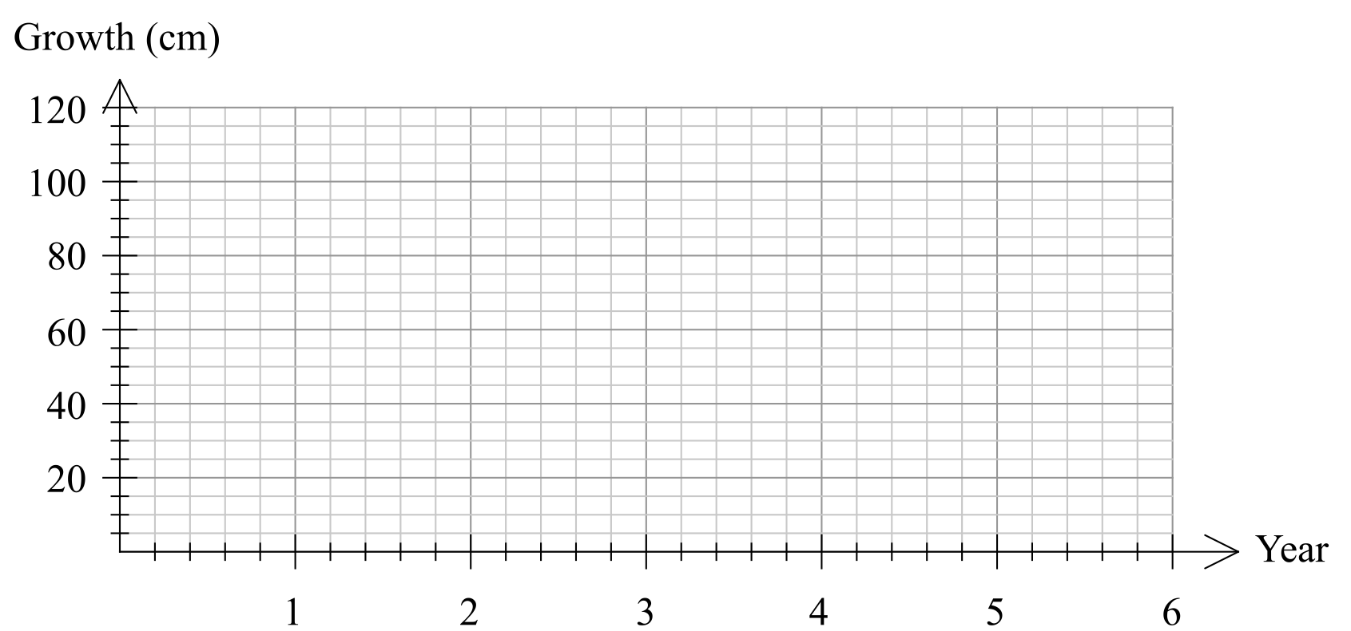
- In which year is the growth of the tree first less than 1 cm? [1]

- Describe height of the tree in the long-term. [1]

- (9 marks)
A fish farm is stocked with 5000 fish. The owners plan to sell 25% of the fish stock throughout the year and then to re-stock the farm with an extra 300 fish at the end of the year. The fish stock, , at the start of year n can be modelled by , where .
- Explain the significance of the 0.75 in the model. [1]
- Complete the table below for the first 8 years, rounding values to the nearest ten. [2]
n | 0 | 1 | 2 | 3 | 4 | 5 | 6 | 7 | 8
 | 5000
- Graph the fish stock at the start of the first 8 years on the axes below. [3]
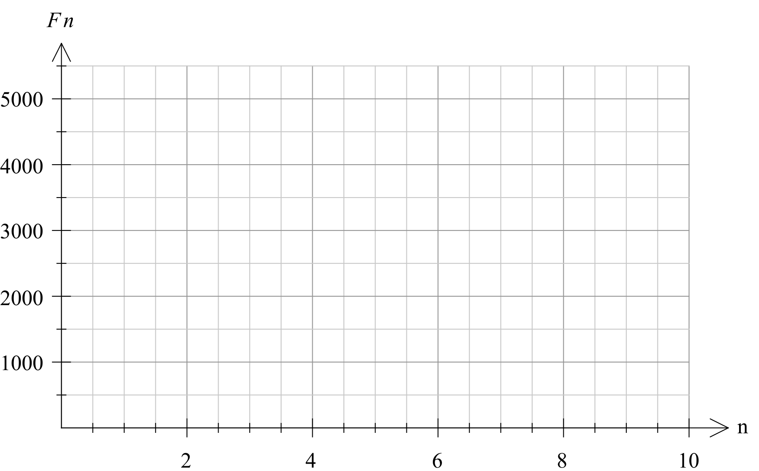
- Comment on how the size of the fish stock is changing over the first 8 years. [1]
- Calculate the expected fish stock after 20 years, and comment on the long-term size of the fish stock according to this model. [2]

- (10 marks)
A study of the population of a rare marsupial found the population growth rate was 9.5% per annum. At the commencement of the study (at the start of 1997) the population was 2000.

  - Write a recursive formula for predicting the population, P, t years after 1997. [2]

  - Predict the population at the start of 2007 (to the nearest whole number). [2]

  - Show clearly that the population t years after 1997 can also be written as where A and b are constants. State the values of A and b. [3]

  - Predict when the population first exceeds 10 000. Show clearly how you obtained your answer. [3]

Extra space for working if required

End of Test

